NATIONAL SOIL SURVEY CENTER
Federal Building, Room 152
100 Centennial Mall North
Lincoln, Nebraska 68508-3866



Soil Survey Technical Note No. 2


Soil Color Contrast

Purpose
This technical note provides uniform definitions for color contrast terms among the Soil Survey Manual (Soil Survey Staff, 1993), the Field Book for Describing and Sampling Soils (Schoeneberger et al., 1998), and the Field Indicators of Hydric Soils in the United States (U.S. Department of Agriculture, 1998). It also describes a new procedure to determine the difference in hue between colors.

Background
In an effort to synchronize the definition among the Soil Survey Manual, the Field Book for Describing and Sampling Soils, and the Field Indicators of Hydric Soils in the United States, a provisional definition for color contrasts was field tested nationally in 1998. After the testing period, a call for final comments was requested regarding final adoption of the provisional definition. The definition and other items contained in this technical note are the result of these collaborations and deliberations.

Introduction
Color contrast is the degree of visual distinction that is evident between one soil color compared with another in close proximity. In this application it is a visual impression of the prominence between a minor color component (mottle or concentration) and an associated major color component (matrix). The Soil Survey Manual provides three categories of soil color contrast:
- faint for contrasts that are evident only on close examination,
- distinct for contrasts that are readily seen but are only moderately expressed, and
- prominent for contrasts that are strongly expressed.
This technical note provides guidelines to help the soil scientist assign contrast terms consistently. Determining soil color contrast is not always simple. Prominent mottles are likely the first thing one notices when observing a freshly broken piece of soil fabric. However, if a fabric has several shades and less contrast, it takes time and concentration to fully record colors and color patterns. The contrast between two colors decreases with decreasing value and/or chroma, and it becomes faint if value is 3 or less and chroma is 2 or less, regardless of differences in hue. Furthermore, there can be a considerable amount of error in distinguishing and contrasting the colors of two features, depending on the water state; the quality of light; the time of day; roughness
of the soil surface; the quantity, size, and shape attributes of the two features; and boundary distinctions. Error can be exacerbated when the two features are among an intricate pattern of other soil colors. Care in the identification of soil colors in the field thus continues to be of primary importance in minimizing errors.

Definitions of soil color contrast terms

Note: If the mottle and matrix both have values of ≤ 3 and chromas of ≤ 2, the color contrast is Faint, regardless of the difference in hue.
Faint - Evident only on close examination. The contrast is faint if the:
- difference in hue = 0, difference in value is <2, and difference in chroma is <1, or
- difference in hue = 1, difference in value is <1, and difference in chroma is <1, or
- difference in hue = 2, difference in value = 0, and difference in chroma = 0, or
- difference in hue is ≥ 3 and both colors have values of <3 and chromas of <2.
Distinct - Readily seen but contrast only moderately with the color to which compared. The contrast is distinct if the:
- difference in hue = 0, and
- difference in value is <2 and difference in chroma is >1 to <4, or
- difference in value is >2 to <4 and difference in chroma is <4.
- difference in hue = 1, and
- difference in value is <1 and difference in chroma is >1 to <3, or
- difference in value is >1 to <3, and difference in chroma is <3.
- difference in hue = 2, and
- difference in value = 0 and difference in chroma is >0 to <2, or
- difference in value is >0 to <2 and difference in chroma is <2.
Prominent - Contrasts strongly with the color to which compared. Color contrasts that are not faint or distinct are prominent.

Table 1 - Tabular key for contrast determination using Munsell® notation
Note: If both colors have values of ≤ 3 and chromas of ≤ 2, the color contrast is Faint (regardless of the difference in hue).
Hues are the same (Δ h = 0) |  |  | Hues differ by 2 (Δ h = 2)
Δ Value | Δ Chroma | Contrast | Δ Value | Δ Chroma | Contrast
0 | ≤1 | Faint | 0 | 0 | Faint
0 | 2 | Distinct | 0 | 1 | Distinct
0 | 3 | Distinct | 0 | ≥2 | Prominent
0 | ≥4 | Prominent | 1 | ≤1 | Distinct
1 | ≤1 | Faint | 1 | ≥2 | Prominent
1 | 2 | Distinct | ≥2 | --- | Prominent
1 | 3 | Distinct
1 | ≥4 | Prominent
≤2 | ≤1 | Faint
≤2 | 2 | Distinct
≤2 | 3 | Distinct
≤2 | ≥4 | Prominent
3 | ≤1 | Distinct
3 | 2 | Distinct
3 | 3 | Distinct
3 | ≥4 | Prominent
≥4 | --- | Prominent
Hues differ by 1 (Δ h = 1) |  |  | Hues differ by 3 or more (Δ h ≥ 3)
Δ Value | Δ Chroma | Contrast | Δ Value | Δ Chroma | Contrast
0 | ≤1 | Faint | Color contrast is prominent, except for low chroma and value. |  | Prominent
0 | 2 | Distinct |  |  | Prominent
0 | ≥3 | Prominent
1 | ≤1 | Faint
1 | 2 | Distinct
1 | ≥3 | Prominent
2 | ≤1 | Distinct
2 | 2 | Distinct
2 | ≥3 | Prominent
≥3 | --- | Prominent

Procedure for determining the difference between hues
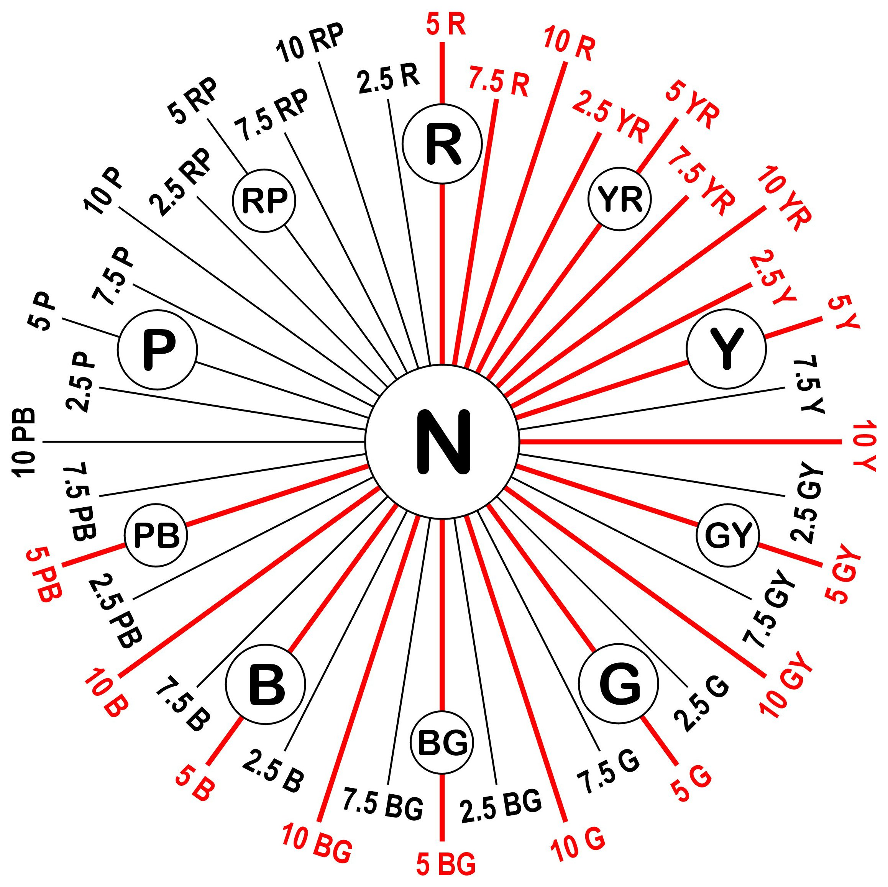
The spokes of the Munsell® hue circle in figure 1 represent hues spaced at intervals of 2.5. Spokes colored red (or in bold if in black and white) are those hues that are approved by the National Cooperative Soil Survey (NCSS) for soil color determinations. In a clockwise direction in figure 1, the
NCSS-approved hues of 5R through 5Y are spaced at intervals of 2.5. From 5Y through 5PB, the hue spacing changes to 5-unit intervals.
Figure 1.⎯Munsell® hue circle (modified from
Munsell Book of Color, 1976).
To determine the "difference in hue" between colors, count the number of 2.5-unit intervals. For example, hues of 2.5Y and 7.5YR differ by two 2.5-unit intervals, and so their difference in hue is counted as "2." Hues of 5Y and 5GY differ by four 2.5-unit intervals, and so their difference in hue is counted as "4."
The suggested procedure is to write down the colors as observed, then to determine the difference between hues, rather than count pages. The old technique of counting the number of page separations to record the difference in hue is not recommended for the following reasons:
- It is difficult to know the interval spacing where hues may occur on the same page, such as on the Munsell® color gley charts and on the recently approved 10Y-5GY color chart from MUNSELL® Soil Color Charts, by GretagMacbeth.
- Hue pages might be missing, or they might be disorganized relative to the ordered progression of the Munsell® hue circle (figure 1).
- Although separate hues may occur on adjacent pages, their hue spacing may be either 1 or 2, depending on whether the hues are at 2.5- or 5-unit intervals (figure 1).
- The same hue can occur on adjacent pages, such as in the EarthColors™ soil color book, from Color Communications, Inc.

References
Munsell book of color. 1976. Macbeth, a Division of Kollmorgen Corp., Baltimore, MD.
Schoeneberger, P.J., D.A. Wysocki, E.C. Benham, and W.D. Broderson. 1998. Field book for describing and sampling soils. Version 1.1. USDA-NRCS, National Soil Survey Center, Lincoln, NE (http://soils.usda.gov/procedures/field_bk/main.htm).
Simonson, R.W. 1993. Soil color standards and terms for field use⎯history of their development. In Bigham, J.M., and E.J. Ciolkosz (eds.) Soil Color, pp. 1-20. Proc. Symposium sponsored by Divisions S-5 and S-9 SSSA, San Antonio, TX. 21-26 Oct. 1990. SSSA Spec. Publ. 31. ASA, CSSA, and SSSA, Madison, WI.
Soil Survey Staff. 1993. Soil survey manual. SCS. U.S. Dep. Agric. Handb. 18. U.S. Gov. Print. Office, Washington, D.C. (http://soils.usda.gov/procedures/ssm/main.htm).
U.S. Department of Agriculture. 1998. Field indicators of hydric soils in the United States. Hurt, G.W., P.M. Whited, and R.F. Pringle. (eds.). Version 4.0. USDA, NRCS, Ft. Worth, TX (http://soils.usda.gov/soil_use/hydric/field_ind.pdf).

NCSS standards use the color chips recognized in the Soil Color Charts for describing soil pedons in soil survey operations. The color chips included in the Soil Color Charts were selected so that soil scientists can adequately describe the normal range of soil colors. These chips have enough contrast between them for different individuals to match a soil sample to the same color chip. Interpolating between chips is not recommended in standard soil survey operations because visual determinations cannot be repeated with a high level of precision (Simonson, R.W., 1993). Describing soil color by other methods (e.g., a soil color meter) or by interpolating between color chips for purposes outside of routine soil survey is not restrained by NCSS standards (such as for research, special studies, or hydric soil determinations).

